DIGITAL MARKETING

Assignment 1 – Creating a blog. Customizing the theme design and posting a new article with 500 words

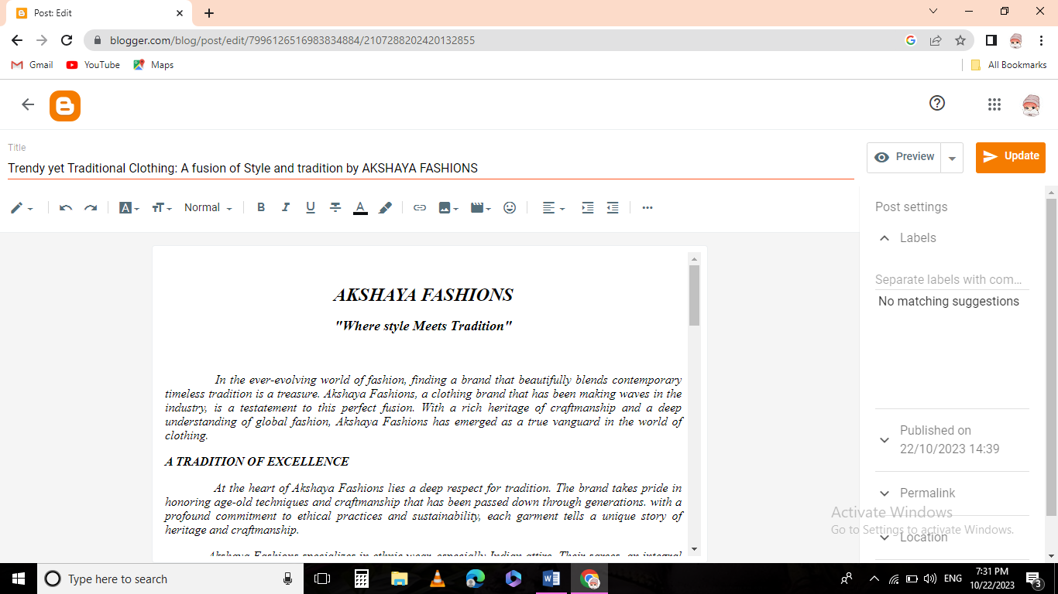

Blogger post link:

<https://www.blogger.com/blog/post/edit/7996126516983834884/2107288202420132855>

Passage:

***AKSHAYA FASHIONS***

***"Where style Meets Tradition"***

*In the ever-evolving world of fashion, finding a brand that beautifully blends contemporary timeless tradition is a treasure. Akshaya Fashions, a clothing brand that has been making waves in the industry, is a testatement to this perfect fusion. With a rich heritage of craftmanship and a deep understanding of global fashion, Akshaya Fashions has emerged as a true vanguard in the world of clothing.*

***A TRADITION OF EXCELLENCE***

*At the heart of Akshaya Fashions lies a deep respect for tradition. The brand takes pride in honoring age-old techniques and craftmanship that has been passed down through generations. with a profound commitment to ethical practices and sustainability, each garment tells a unique story of heritage and craftmanship.*

*Akshaya Fashions specializes in ethnic wear, especially Indian attire. Their sarees, an integral part of Indian culture, are more than just pieces of fabric; they are works of art. The intricate hand-embroidery and weaving techniques that have been perfected over centuries come alive in each sarees. Every thread tells a story, making the wearer not just a fashion enthusiast, but a custodian of history.*

***A CONTEMPORARY TWIST***

*While tradition is the core of Akshaya Fashions, The brand does not shy away from embracing contemporary trends. Our designs effortlessly fuse the classic with the modern, creating a unique and captivating blend. Whether it is an intricately designed lehenga for a grand wedding or a casual yet elegant kurta for everyday wear, Akshaya Fashions offers a diverse range of clothing that caters to various tastes and occasions.*

*The color palette at Akshaya Fashions is a visual delight, encompassing a wide range of hues that cater to different moods and seasons. From the vibrant reds and pinks of festival wear to soothing pastels for a more casual look, our color choices are a reflection of the brand's versatility.*

***QUALITY THAT SPEAKS VOLUMES***

*One of the distinguishing features of Akshaya Fashions is its unwavering commitment to quality. Each garment is a testament to the brand's dedication to delivering the finest in terms of fabric, design and craftmanship. Every piece undergoes rigourous quality checks, ensuring that customers receive products that are not only beautiful but also durable.*

*The use of premium fabrics and materials is non-negotiable for Akshaya Fashions. The brand believes that quality is not just about making a garment that looks good for a season; it's about creating clothing that withstands the test of time.*

***CUSTOMER-CENTRIC APPROACH***

*What sets Akshaya Fashions apart is its deep-rooted belief in the importance of the customer. They understand that clothing is a personal statement, an expression of one's individuality. The brand's customer-centric approach is reflected in their made-to-order service, where customers can customize their garments to suit their unique preferences.*

*Their online platform is user-friendly, providing an effortless shopping experience. With detailed product descriptional and a responsive customer support team, they aim to make every purchase a seamless journey from selection to delivery.*

***A BRAND FOR ALL OCCASIONS***

*Akshaya Fashions caters to a wide range of occasions. Whether you're looking for the perfect bridal attire, elegant evening wear or something casual for your everyday wardrobe, this brand has you covered. Their versatility ensures that they remain a go-to destination for all your fashion needs.*

*In conclusion, Akshaya Fashions is a brand that stands at the confluence of tradition and contemporary fashion, offering a range of clothing that is steeped in culture yet adaptable to the ever-changing style landscape. With a commitment to quality, a customer-centric approach and a rich heritage, this brand is making a mark in the fashion industry. Akshaya Fashions invites you to experience the elegance of timeless tradition and the excitement of modern style in one harmonious collections.*

***"Elegance Knows No Bounds***

***When Tradition Meets Trend In The World Of Clothing"***